学习任务单
课题 | Section B
学段/年级 | 初中 八年级 | 学科 | 英语
教材 | 英语 人教版 八年级 上学期
章节 | Section B
学习目标
During this class, you should be able to:
1.master and know how to use the key words and expressions:That's why...，serious, as long as, necessary, be different from, win, bring out the best, be the same as etc.;
2.know how to use the comparatives to compare and describe people;
3.to get the main idea of a paragraph by finding its topic sentence;
4.To get the key points of the three passages on whether friends should be the same or different.
课前学习任务
1.请在101智慧课堂教育平台上完成以下问题的讨论。
1)Who is your best friend?
2)In your eyes, what is a good friend?
3)Do you argue with your friend? Why?
4)Do you know any sayings about friends?
2.请在101智慧课堂教育平台上完成基础知识前置作业。（具体见附件“练习与测验”）
3.Please read the following saying about friendship and appreciate the value of choosing a friend conveyed by these sayings. 请阅读下列与友谊相关的格言诗词，并体会其所传达的择友观。
A friend in need is a friend indeed. 患难见真情。
A friend is easier lost than found . 得朋友难，失朋友易。
True friendship lasts forever. 真正的友谊地久天长 。
Old friends and old wines are best. 陈酒味醇，老友情深。
A life without a friend is a life without a sun. 人生在世无朋友，犹如生活无太阳。
It is a pleasure to have friends come from afar有朋自远方来，不亦乐乎。
However deep the Lake of Peach Blossom may be, it 's not so deep, Oh Wang Lun! As your love for me. 桃花潭水深千尺，不及汪伦送我情。
If you have friends who know your heart,distance cannot keep you apart. 海内存知己，天涯若比邻。
A Gentleman's friendship is as thin as water, a villain's is as sweet as wine. 君子之交淡如水，小人之交甘若醴。
课上学习任务
1.Please read the text about Huang Lei and complete the ID card.
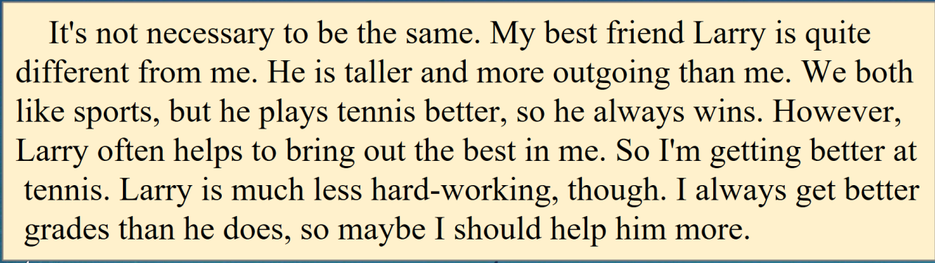
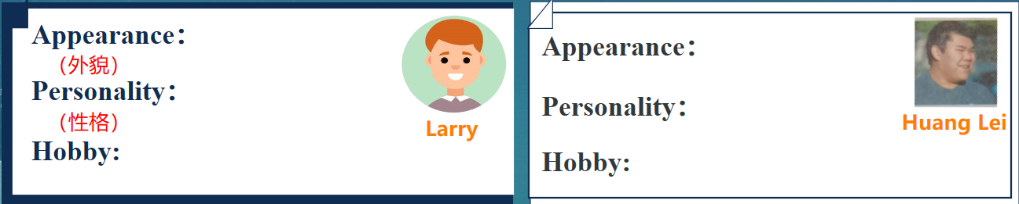
2.Please read the text about Mary and complete the mind map.
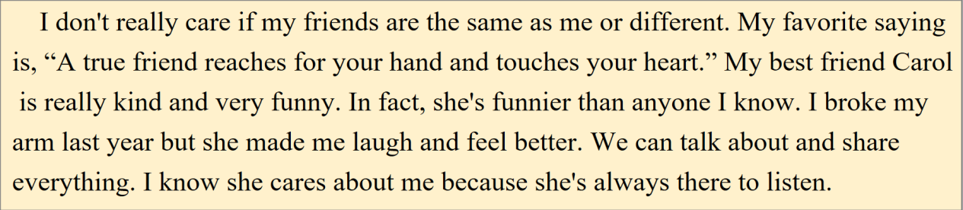

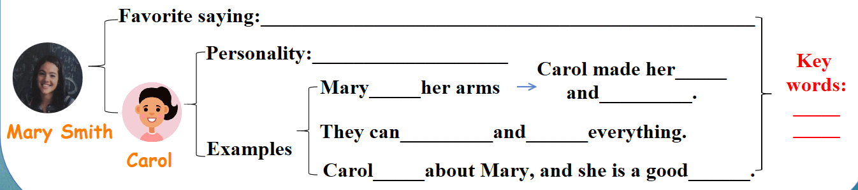

3.Group work.
8 students in a group. Discuss with your group members your opinion on friendship (8人一组，合作回答以下问题并完成文本填空).
(1) What is friendship like?What is a good friend? (学生1，学生2)
(2) Draw a picture of friendship and stick(贴)it on the blackboard. (S3,S4)（友谊像什么？画一张图片并将其粘贴到黑板上。）
(3) What’s your favorite saying about friends?Why?(S5,S6)
(4) Make a report on the stage.(All together.)
(完成任务后上台进行汇报。)
In our eyes, friendship is like______________________.
My best friend is__________.
He/She ________________than________.I_________as_________
as_________.We both like_____________________________________
However,___________________________________________________
I think a good friend __________________________________________
Our favorite saying is_____________________________________
Because____________________________________________________

推荐的学习资源
1.为了了解更多元化的友谊，推荐观看以下电影：《绿皮书》、《忠犬八公的故事》、《闻香识女人》等；
2.可学唱一首英语歌曲，如《Forever friends》,《The more we got together》等；
3.推荐阅读马克思恩格斯的故事、《三国演义》、伯牙子期的故事等。

