教案
课题 | Section A
学段/年级 | 初中 八年级 | 学科 | 英语
教材 | 英语 人教版 八年级 下学期
章节 | Section A
教材解读
本课例选自人教版新目标英语教材八年级下册第七单元Section A 3a部分，单元主题契合人与自然、人与社会、人与自我，Section A部分主题主要为世界地理之最，语用目标为能够正确使用最高级谈论地理知识，本课主题为“Qomolangma---the most dangerous mountain in the world?”，通过本课学习，学生能对珠穆朗玛峰有更多的了解，学会用英语表述地理，在阅读的过程中，体悟攀登者的精神，鼓励学生遇到困难永不言弃，敢于挑战自己，实现梦想。
学情分析
本班为信息化教学班，学生英语学习积极性高，课堂表现佳，对学习英语有一定的兴趣和热情，大部分学生配合老师的教学工作，愿意开口表达，积极回答问题，勤于探究思考，达到了教学共长的效果。教学设计根据学情采取分层教学与分层作业设计，尽可能满足不同层次学生的学习需求。整体而言，本班学生学习劲头足，但仍有上升空间，还需不断努力。在学习本课前，学生已经掌握了一定的听说读写知识，大部分同学达到了八年级下册要求掌握的语言能力。此外，学生对地理知识也有所了解，对“世界地理之最”“中国地理之最”等知识掌握地较好。因此，在本课教学中，教师应依据学生实际情况，立足学生已掌握的语言知识和文化背景等知识，在新课标背景下，优化教学方式，灵活运用信息化教学手段，深挖语篇，启发思维，提升学生的英语学习能力，提升学科核心素养。
教学工具
平板、希沃白板、VR实景、第二课堂、导学案、图片、音频、视频
教学目标
By the end of the lesson, students will be able to
Language ability:
1. have a good command of the new words and phrases, such as challenge, fact, spirit, achievement, the most dangerous, the forces of nature and so on;
2. grasp the general idea and detailed information of the whole article;
Thinking capacity:
1. think broadly, deeply and dialectically about why the climbers climb Qomolangma and what we can learn from the climbers' spirit;
2. think deeply about their own challenges and come up with possible solutions;
Culture awareness:
1. arouse a sense of pride for the land of our country;
2. learn from the climbers' spirit of never giving up trying to achieve dreams.
Learning ability:
1. use the new words, phrases and superlatives to talk about Qomolangma and their own Qomolangma;
2. know how to do a research based on articles.
教学重难点
Key points:
1. Students are able to know the meaning and usage of new words, phrases and superlatives;
2. Students are able to understand the text and find the key information by fast reading and careful reading;
Difficult points:
1. Students are able to develop skills such as skimming and scanning;
2. Students are able to think deeply about their own challenges and come up with possible solutions.
教学方法
Situational teaching method;
Communicative language teaching approach;
Task-based language teaching method;
Cooperative learning;
Inquiry learning.
教学过程
环节 | 过程设计
（5分钟） | 1. Pre-task  Teacher has assigned a pad-task the day before the class in order to test students' background knowledge about "Top of the World/China" in geography. The task and students' answers are as follows:  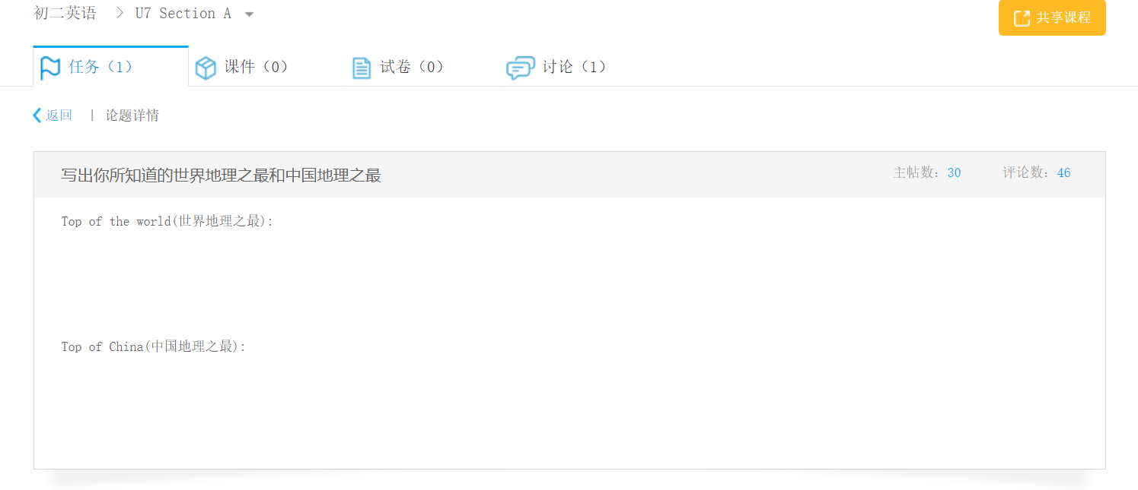  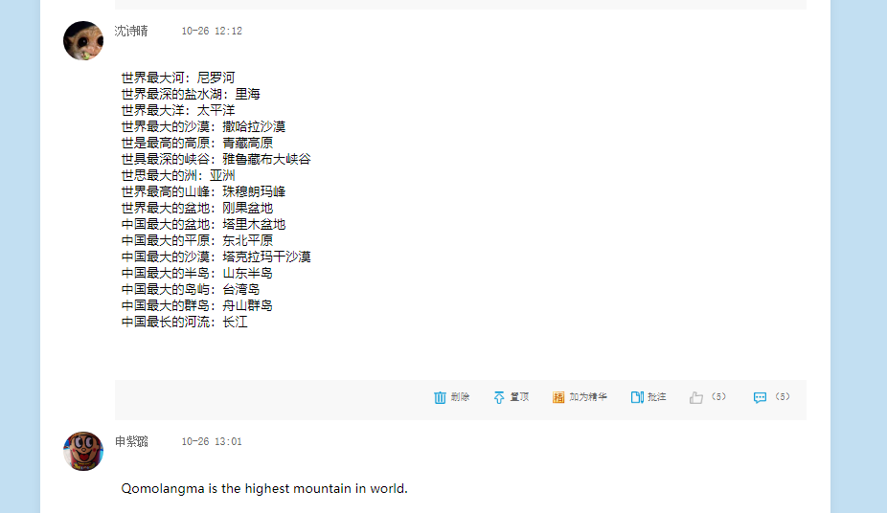  Most of the students have some background knowledge about this topic because they have already learned in geography class. But they don't know how to express these words in English.  At the beginning of the class, teacher shows students their task completion.  2. Warming up  Based on students' pre-task, teacher leads in this class by talking about "Top of the World/China". Pictures of these famous places are presented.  Firstly, talk about "Top of the World"  The highest mountain---_________  The biggest desert---____________  The deepest salt lake---__________  The longest river---_____________  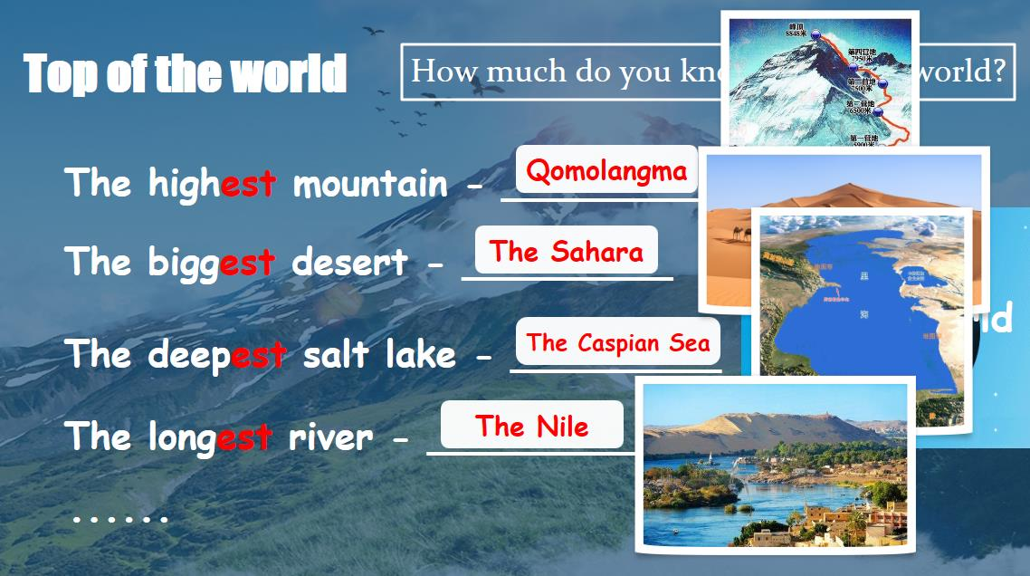  Then, talk about "Top of China"  The highest mountain---_________  The biggest desert---____________  The deepest salt lake---__________  The longest river---_____________  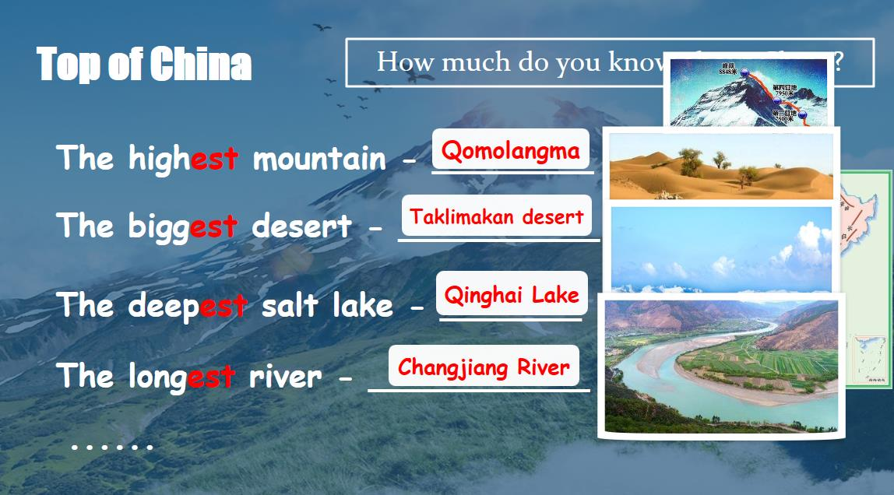
  Step 1: Lead in
（3分钟） | 1. Compare: Find the similarity  ---What is the highest mountain in the world and in China?  ---Qomolangma.  Show students a VR scenery of Qomolangma and ask about their feelings after watching it.  Direct them into the research part by having them discussing their feelings with adjectives.  2. Think: Is Qomolangma the most dangerous mountain in the world?（结合阅读文本，设疑导入，以此问题作为调查主线）  Let's do a geography research together.(以调查为主题）  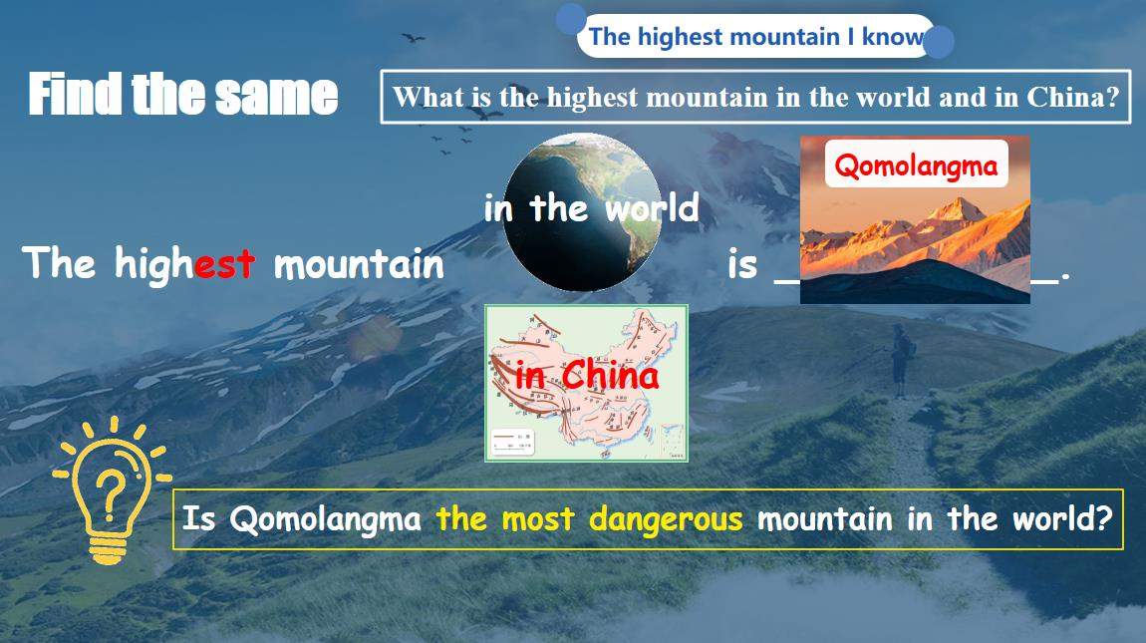  3. Guide students to think how to make a research.  Give some possible ways such as searching on the Internet, reading articles, interviewing, etc.  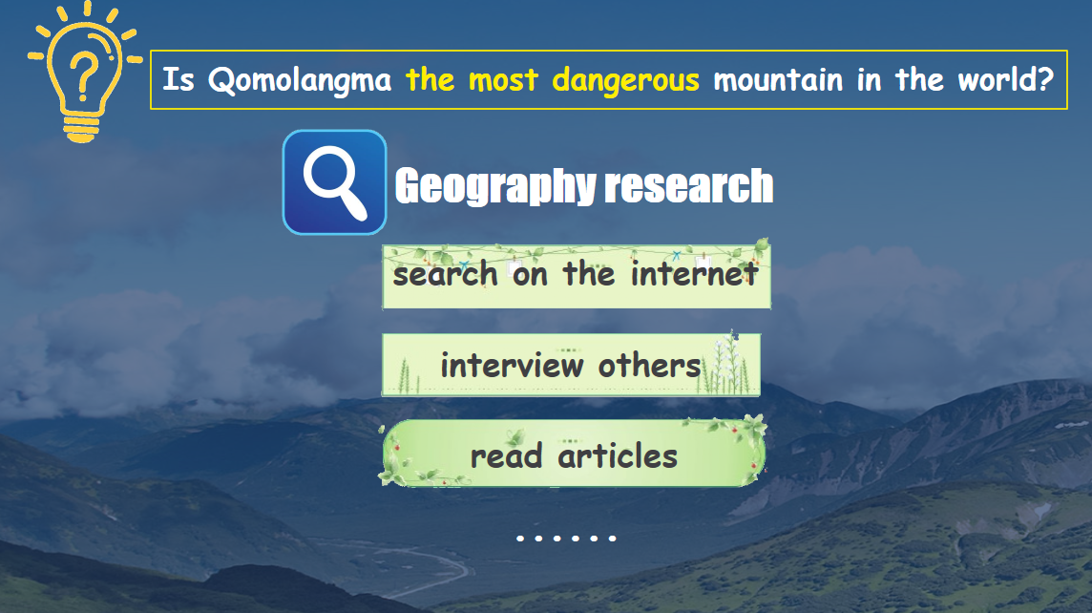
  Step 2: The highest mountain I know
（5分钟） | 1. Collect information to finish the research:  Teacher: What do we learn from the article?  Skim the text and tell me with three key phrases.  Then match the main ideas.  Students:  Para.1 Facts and dangers  Para.2 Achievements of climbers  Para.3 Spirit of climbers  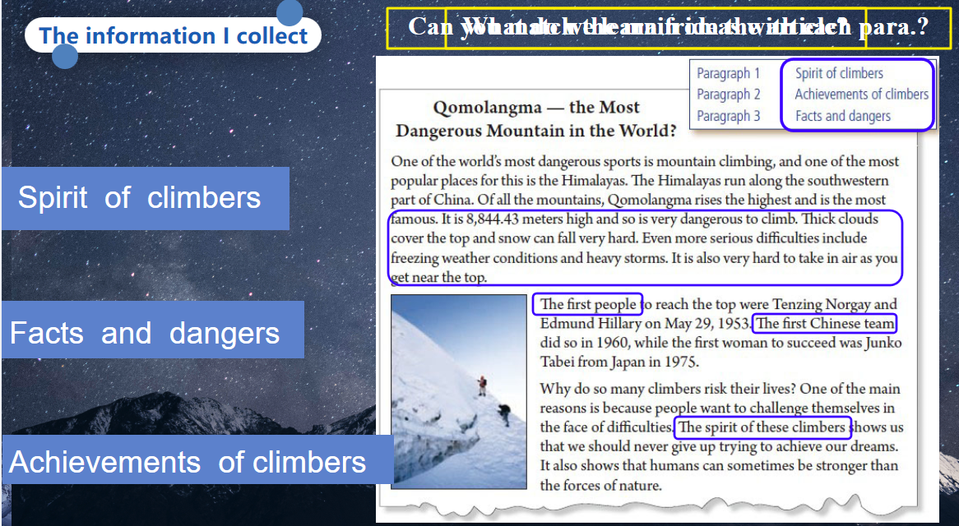
  Step 3: The information I collect
（20分钟） | 1. Let students finish the research by collecting more information from 3 aspects.  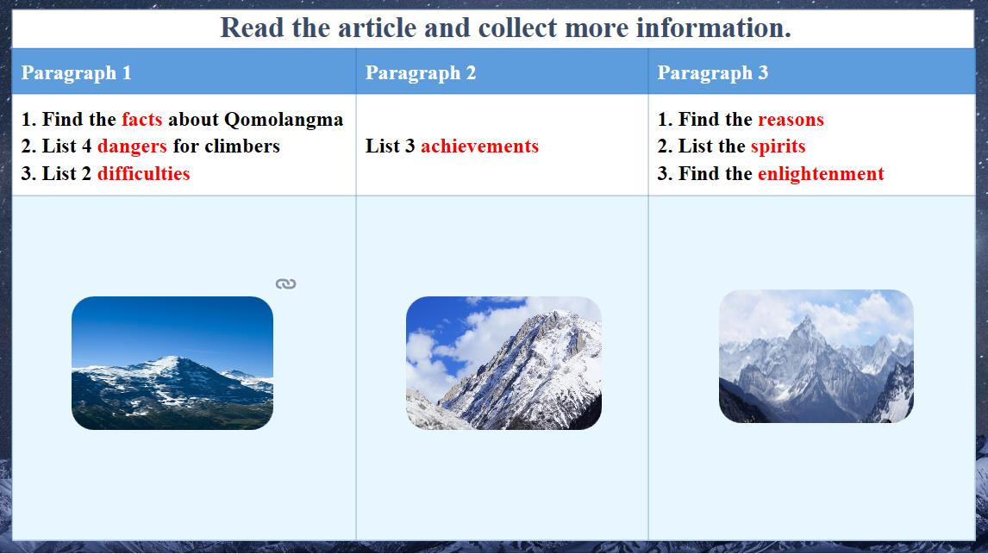  2. Ask students to collect information about facts and dangers:  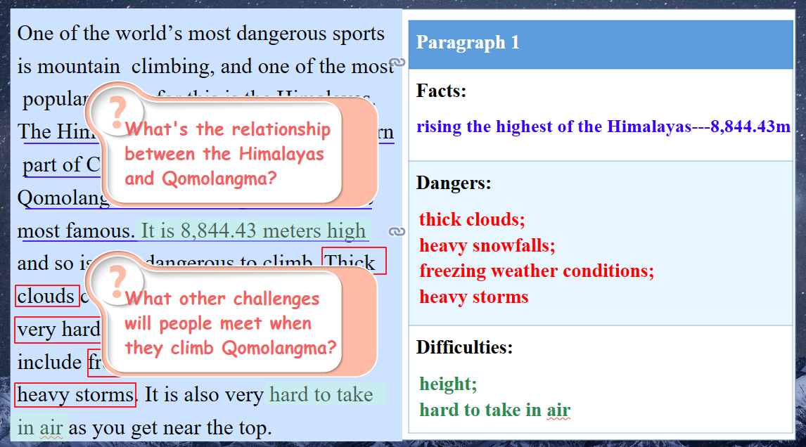  3. Explain the relationship between the Himalayas and Qomolangma.（理清两者关系，避免学生混淆）  4. Let Ss think: What other challenges will people meet when they climb Qomolangma?（启发学生发散性思维）  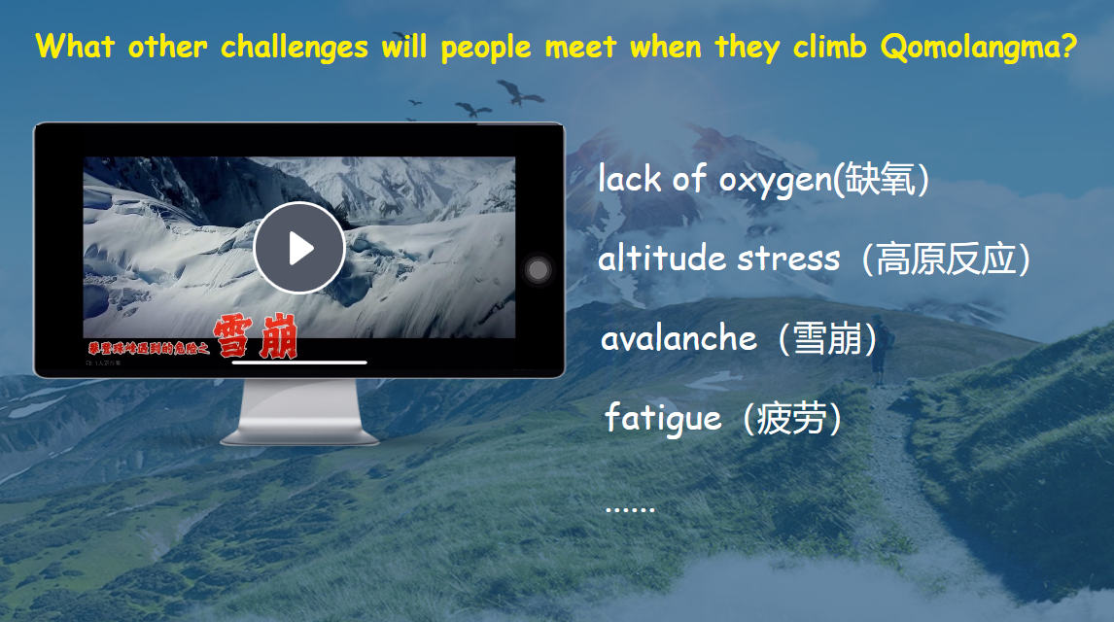
  Step 4: Information about facts and dangers
（5分钟） | 1. Let Ss discuss: Find 3 "first"s in Para. 2 to collect information about achievements.  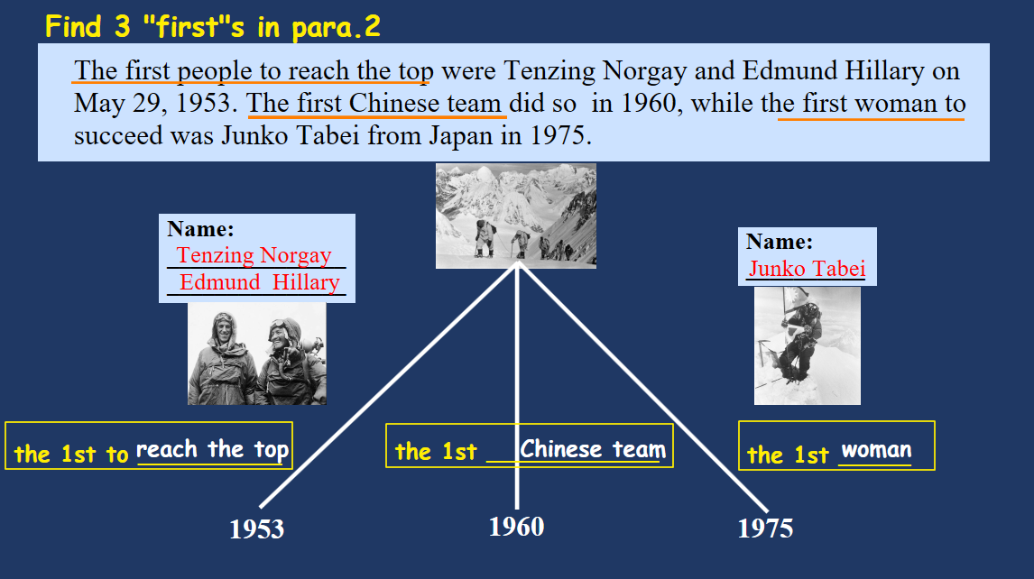
  Step 5: Information about achievements
（5分钟） | 1. Ask Ss the question mentioned at the beginning of the class: Is Qomolangma the most dangerous mountain in the world?（首尾呼应，使得教学过程形成闭环）  Then think: Why do so many people try to climb this mountain even though it is dangerous?  After Ss express their ideas, let them watch a video about the movie The Climbers.  After watching this video, ask how Ss feel and ask why they climb Qomolangma.  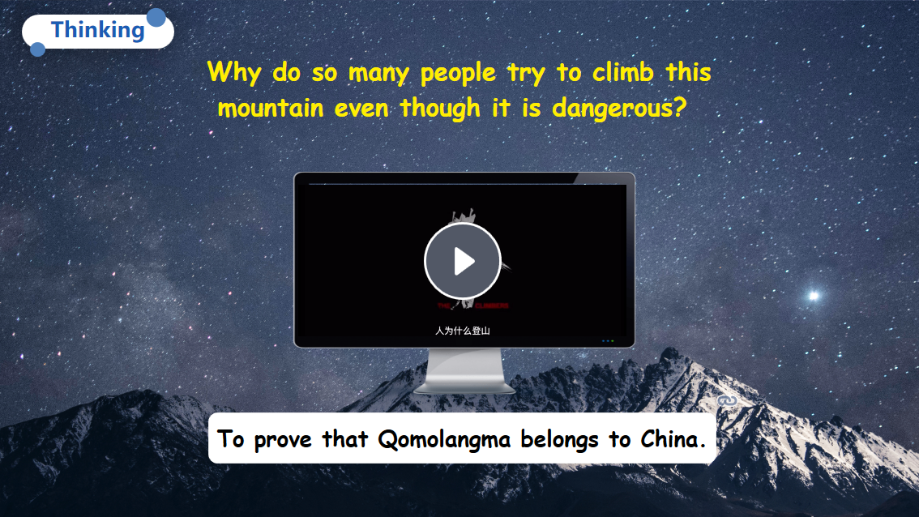  2. Let Ss find more information about the following questions:  - Why do many people climb the mountains?  - What spirit can we learn from the climbers?  - What other spirit can we learn from the passage?  - What do we learn from the passage?  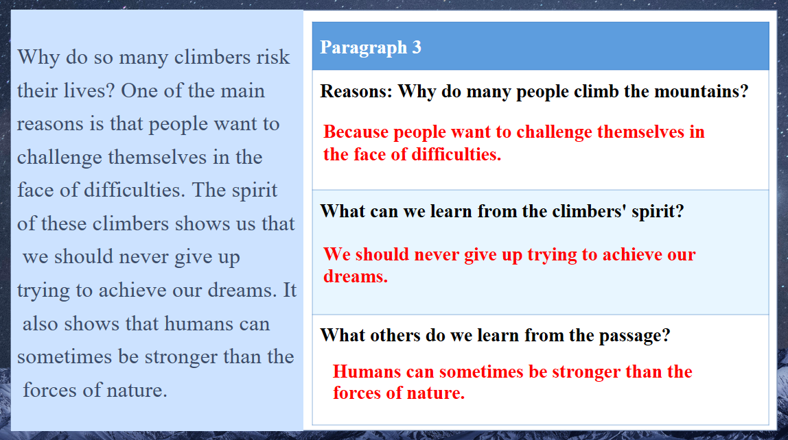  3. Make a conclusion of the research and inspire students to never give up trying to achieve their dreams.  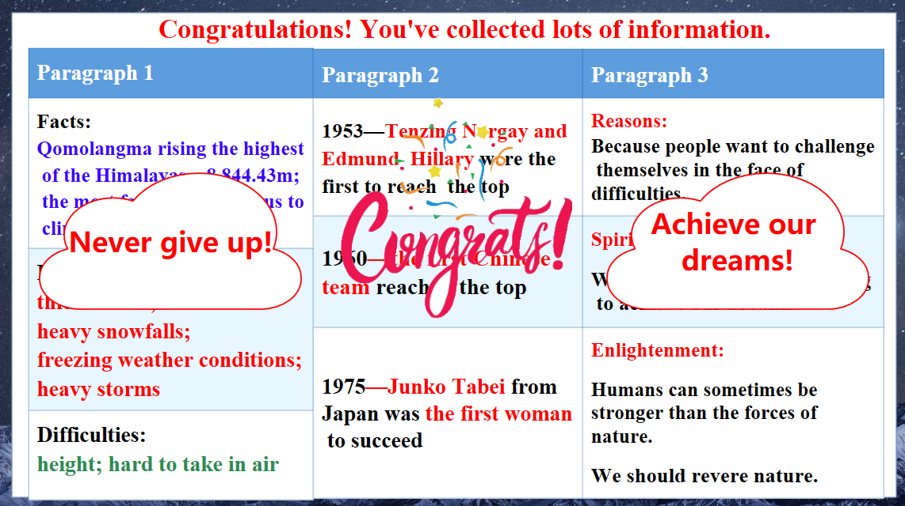
  Step 6: The spirit I learn
（5分钟） | 1. Set up a situation of school broadcasting radio. Let students do a research by interviewing their classmates about "What is your 'Qomolangma'"? and "How do you 'climb' it?" A second class is applied in this step. Students in Grade 9 show how to do an interview.  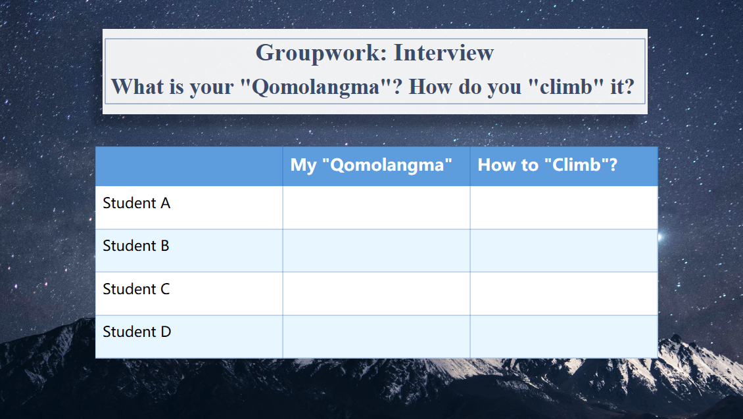  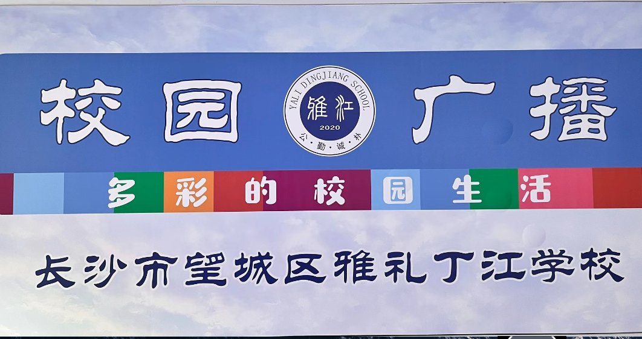2. Assess students' performance, which includes teacher assessment and peer assessment.  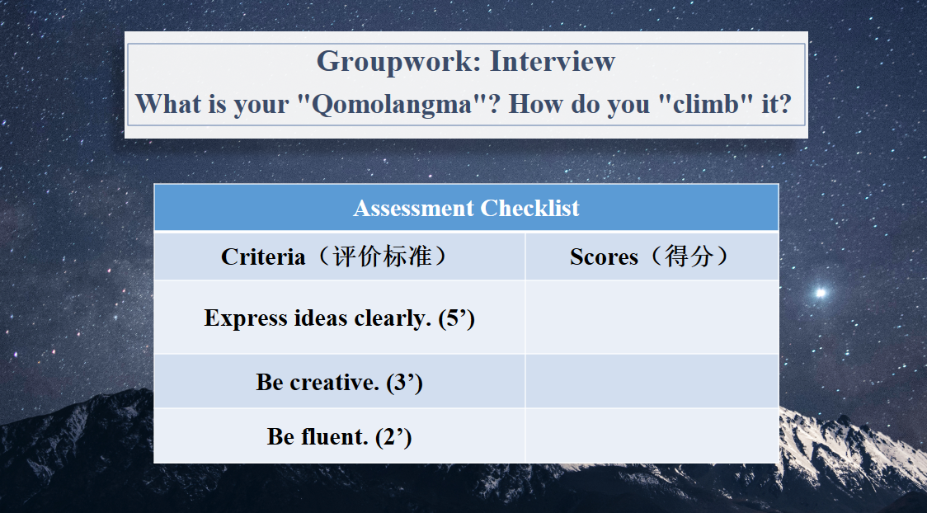
  Step 7: Group work
（2分钟） | Must do: To search on the Internet about a big event in history and share with classmates;  Choose to do:  To describe the event within 150 words;  To search and describe another "Top of the World /China" using superlatives.
  Step 8: Homework
板书设计
