学习任务单
课题 | Section A
学段/年级 | 初中 八年级 | 学科 | 英语
教材 | 英语 人教版 八年级 下学期
章节 | Section A
学习目标
1. Be able to grasp the general idea and detailed information of the whole article;
2. Be able to use the new words, phrases and superlatives to talk about Qomolangma and students' Qomolangma;
2. Be able to know how to do a research based on articles.
课前学习任务
1. To enjoy a video--Climbers.
2.To finish pre-task on intellectual pads.
课上学习任务
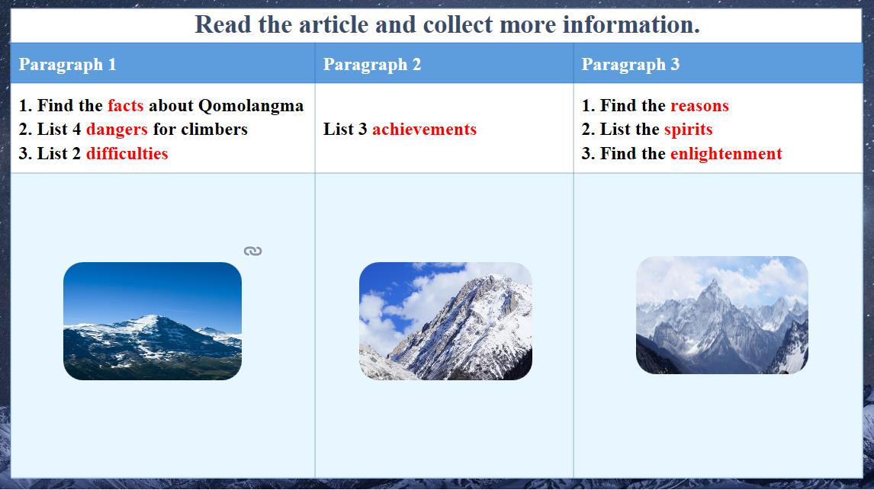
推荐的学习资源
【登山】征服珠穆朗玛峰_哔哩哔哩_bilibili
【纪念中国人登顶珠峰60周年】_哔哩哔哩_bilibili
探路者王静：路由心生_哔哩哔哩_bilibili

