学习任务单
课题 | Section A
学段/年级 | 初中 七年级 | 学科 | 英语
教材 | 英语 人教版 七年级 上学期
章节 | Section A
学习目标
1. 学会正确使用常见的表示颜色的形容词和What引导的特殊疑问句及其答语。
2. 在听说活动中准确获取并表达有关物品的颜色等信息。
3.联系生活实际，与同学相互询问、回答、创造，实现知识与思维能力的迁移。
课前学习任务
To feel the beauty of the colorful world around you during the national day and try to describe it in more than one sentence.
(利用国庆期间去感受身边色彩斑斓的世界之美，以图片或者视频的形式在101智慧课堂进行提交，并用一句以上的英文来进行描绘。）
课上学习任务
【Enjoy the Beauty】
- Fill in the blanks with colors.
as as grass
as as snow
as as night
as as our national flag(国旗)
as as rape flowers (油菜花)
as as Chaka Salt Lake (茶卡盐湖)
as as the beach in Fuxian Lake (抚仙湖)
【Find the beauty】
1.Listen and color.
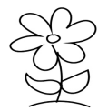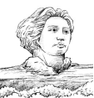
2. Listen and fill in the blanks.
The maple leave is .
The flower is .
The statue(雕像) is .
3. Chain Work Find the colors around us.
【Create the beauty】
Class Uniform Design
Rules:
1. 4 students in a group. 四人一组
2. Try to design the uniform to make it meaningful and beautiful.
尝试设计班服让其有意义并且美观。
3. Try to describe the colors of some things on the class uniform.
试着描述班服上物品的颜色。
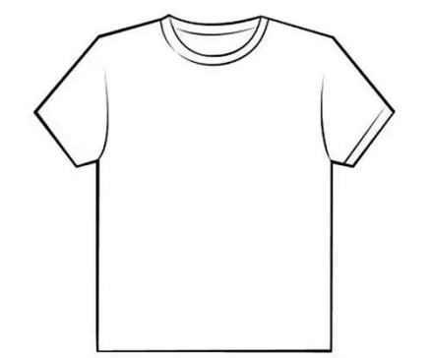
Show & Evaluate
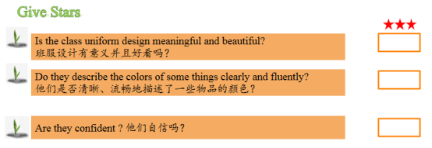
【Homework】
Must do: Draw a map of your bedroom and try to describe it in at least 5 sentences.
Choose to do:
1. Watch the opening ceremony of the Asian Games to enjoy the beauty of Chinese art.
2.“颜”外之意 划线的颜色短语在句中是什么意思？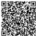
When you are sad, you can say you " feel blue ". ( )
When you fall（跌倒）, your legs can be " black and blue ". ( )
When you are young, you can say you are " in the green " ( )
My brother is the black sheep of my family. ( )
Miss Green is new to this school, so she is a green hand in teaching. ( )

推荐的学习资源
长沙智慧教育公共服务平台 https://rrt.csedu.gov.cn/mgtv/wx/list/yd
七年级英语【第二周】Starter Unit3 What color is it?

