Starter Unit3 What color is it?
Beautiful Colors, Wonderful World.
导学案
【Admire the Beauty】
- Appreciate the beauty of colors(赏颜色之美）
Fill in the blanks with colors. (用颜色词语填空)
as as grass
as as snow
as as night
as as our national flag(国旗)
as as rape flowers (油菜花)
as as Chaka Salt Lake (茶卡盐湖)
as as the beach in Fuxian Lake (抚仙湖)

【Find the Beauty】
1. Listen and color the things.
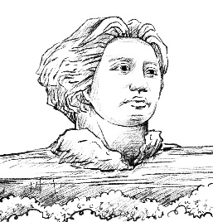
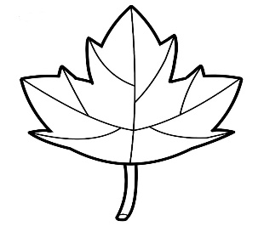
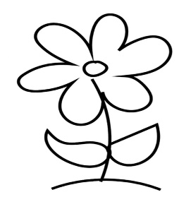
- Listen and fill in the blanks.
The maple leave is .
The flower is .
The statue(雕像) is .
【Create the Beauty】
Class Uniform Design (班服设计）
Rules:
1. 4 students in a group. 四人一组
2. Try to design the uniform to make it meaningful and beautiful.
尝试设计班服让其有意义并且美观。
3. Try to describe the colors of some things on the class uniform.
试着描述班服上物品的颜色。
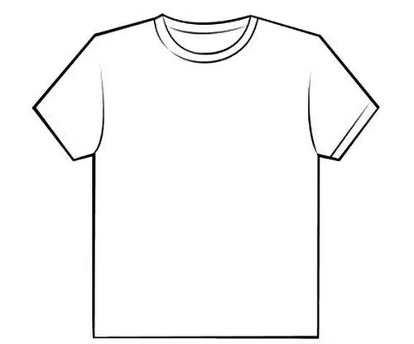
Show & Evaluate
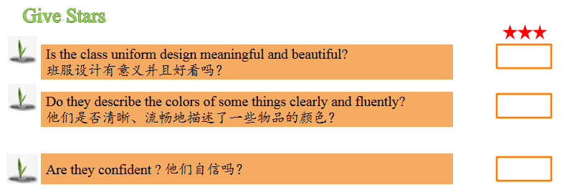
【Homework】
Must do: Draw a map of your bedroom and try to describe it in at least 5 sentences.
Choose to do:
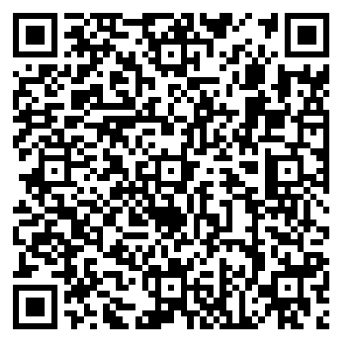
1. Watch the opening ceremony of the Asian Games to enjoy the beauty of Chinese art.
2.“颜”外之意 划线的颜色短语在句中是什么意思？

When you are sad, you can say you " feel blue ". ( )
When you fall（跌倒）, your legs can be " black and blue ". ( )
When you are young, you can say you are " in the green " ( )
My brother is the black sheep of my family. ( )
Miss Green is new to this school, so she is a green hand in teaching. ( )

